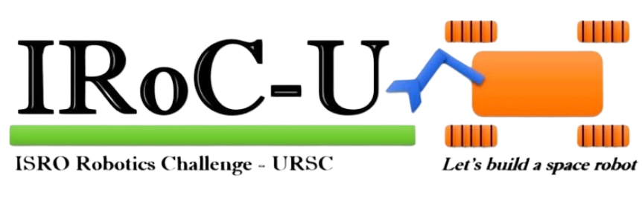
Design Report

By

OBSERACT
Team ID-10487

May 2024

JADAVPUR UNIVERSITY
KOLKATA

ACKNOWLEDGEMENT
We express our sincere gratitude to Prof. Sayan Chatterjee and Prof. Dipankar Sanyal for their invaluable mentorship and guidance. Their expertise significantly contributed to the successful completion of this project. We also acknowledge the insightful technical advice provided by our senior colleagues and other professors, which enhanced our understanding of the project’s complexities. Furthermore, the dedicated efforts of our team members ensured the timely execution and finalization of the project. We extend our appreciation to the workshop and lab assistance and staff for their technical support and assistance with the analysis and fabrication processes. Finally, we recognize the valuable resources consulted throughout the project, which significantly aided our research and development efforts.

INDEX
Content
- Abstract………………………………………………………………. 4
- Introduction……………………………………………………………4
- Technical Specifications……………………………………………..5
  - Rover Mobility………………………………………………….5
    - Mechanism design
    - Drive electronics design
    - Design calculations
    - Sensor system
    - Software requirements and its design details
    - Specifications of COTS components
  - Navigation and identification…………………………………..12
    - Algorithms
    - Software requirements and design details
  - Manipulator…………………………………………………….15
    - Mechanism design
    - Drive electronics design
    - Design calculations
    - Sensor system
    - Software requirements and design details
    - Specifications of COTS components
  - Communications……………………………………………..22
    - RF design
    - Design calculations
    - Software requirements and design details
    - Specifications of COTS components
  - Emergency response system……………………………….24
    - Kill switch design
  - Analysis……………………………………………………….. 25
  - Test plan……………………………………………………….26
  - Weighing and dimensional measurement details of the rover (Rover alone) …………………………………………………29

1. ABSTRACT
This technical report presents the design, development, and implementation of an autonomous rover equipped with a rocker-bogie mechanism. The rover is designed to navigate challenging terrains with enhanced stability and mobility, achieved through the innovative integration of the rocker-bogie suspension system. The report outlines the theoretical framework underlying the rocker bogie mechanism, discussing its advantages in traversing uneven surfaces while maintaining stability. Furthermore, it details the design process, including mechanical configurations, material selection, and integration of sensors and actuators for autonomous navigation. The implementation phase is elucidated, covering assembly procedures, software architecture, and control algorithms employed to achieve autonomous operation. Performance evaluation tests conducted in simulated and real-world environments demonstrate the effectiveness of the proposed rover in negotiating diverse terrains. The results underscore the robustness and versatility of the rocker bogie mechanism, highlighting its potential for applications in planetary exploration, search and rescue missions, and terrestrial exploration. This report contributes valuable insights into the advancement of autonomous rover technology, particularly in enhancing mobility and stability across challenging terrains.

2. INTRODUCTION:
This report is an overview and insight into the technical details of the Rover built by the students of Jadavpur University. A robot is to be built to compete in the IRoC-U 2024, a robotics challenge hosted by the prestigious Indian Space Research Organization (ISRO).
There are few scenarios in which the robots will be required to perform varying tasks, they are as follows: -
- Site Survey: Perform a remote survey to determine the precise coordinates (including altitude) of ﬁeld markers that are unreachable by the rover.
- Rover Mobility: On a 15˚ gradient, move at a pace of 1 to 5 cm/s on various grades. Scaling barriers that are positioned on a level surface, the whole Rover must pass through the barrier. Traversing one metre from the starting point via a hemispherical crater that was created on a level surface. The entire crater must be traversed by the rover.
- Crater detection and obstacle avoidance: Detection and avoidance of the craters and obstacles using sensors in loop.
- Pick and place mechanism by Manipulator: The manipulator needs to pick up an object then traverse a particular distance and place the object at the ground surface.
- Live telemetry feed demonstration: The rover needs to send the sensor data, live path planning data in graphical form or as coordinates back to the base station.
- Kill switch demonstration: Demonstration of power cut-off to all the actuators on assertion of kill switch.
All tasks must be completed in a certain time limit, usually ranging between 40 minutes. All operators of the rover must not be able to view the rover directly. All control must be performed using onboard cameras and/or sensors. The weight and value of the robot is limited to 50 kg and Rs. 5lacs.

3.TECHNICAL SPECIFICATIONS
3.1. Rover Mobility
3.1.1. Mechanism Design
This report presents the design rationale and technical specifications for the Rover's mobility system. The system leverages a well-established rocker-bogie suspension configuration, coupled with high-torque stepper motors, to deliver robust and efficient locomotion on the outer space. This design prioritizes stability, manoeuvrability, and reliable operation in the harsh environment, ensuring successful mission execution.
- Suspension System
The mobility system employs a rocker-bogie suspension. This configuration offers several advantages for outer space exploration:
- Independent Wheel Articulation: Each wheel is mounted on an independent bogie arm, allowing for independent movement and maintaining contact with the uneven terrain. This enhances traction, stability, and obstacle clearance compared to a rigid suspension system.
- Enhanced Stability: The independent bogies allow each wheel to conform to the sand surface, maintaining contact and preventing the rover from tipping over in uneven terrain.
- Improved Maneuverability: The rocker-bogie system permits the rover to turn tightly by differentially controlling the speed of the wheels on each bogie. This is crucial for navigating around obstacles and maneuvering in confined spaces.
- Increased Obstacle Clearance: The high ground clearance provided by the rocker-bogie system allows the rover to traverse over rocks, craters, and other obstacles encountered on the outer space surface.
- Simplified Design: Rocker-bogie systems offer inherent simplicity compared to complex suspension systems, leading to reduced weight and improved maintainability.
- Differential Steering: The rover will employ differential steering for precise control and tight manoeuvring. This technique varies the speed or direction of individual wheels on opposite sides (left/right) to achieve turns.
- Future Considerations: Future iterations may explore omni-directional wheels, enabling lateral movement in addition to forward and backward for enhanced maneuverability in confined spaces.
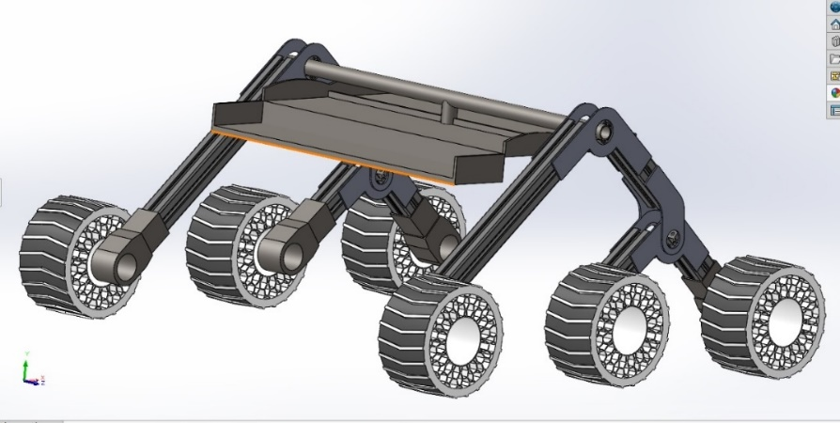

Fig 1: Rover body mechanism

- Wheel and Drive Train
- Wheels: The rover will utilize six specially designed wheels with a robust tread pattern optimized for regolith grip and minimal wear. Material selection will prioritize durability in the outer space environment.
- Motors: Each wheel will be driven by a high-torque, 24V, 54 kg-cm Bipolar Planetary Geared Stepper Motor (Fig 3). These motors offer:
  - Precise Control: Ideal for accurate maneuverability on the outer space surface.
  - High Torque Output at Low Speeds: Well-suited for outer space gravity conditions.
  - Simplified Control: Compared to DC motors, stepper motors require less complex control systems.

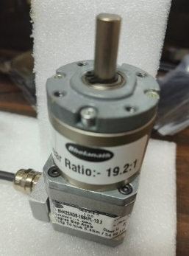
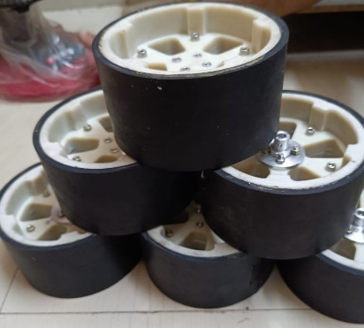

Fig 3: Wheel Motor

Fig 2: Rover Wheel

3.1.2 Drive Electronics Design
The drive electronics system comprises two key components working in concert to achieve precise and safe rover movement:
- Wheel Drive Board: This board features a central processing unit (CPU) built around an STM32 microcontroller. It houses dedicated motor drivers to translate digital signals into power signals for the stepper motors. The system prioritizes safety through features like:
  - Current Limiting: Safeguards motors from overload and potential damage by regulating the amount of current they can draw.
  - Thermal Monitoring: Ensures electronics operate within safe temperature ranges by monitoring operating temperatures and taking corrective actions like reducing motor power or initiating system shutdown if necessary.
  - Emergency Stop Functionality: Allows for immediate power cutoff in critical situations, protecting the rover and its components.
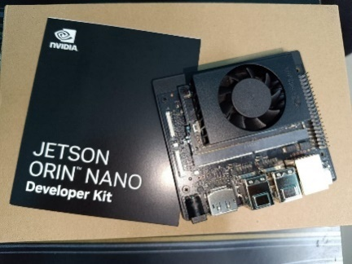
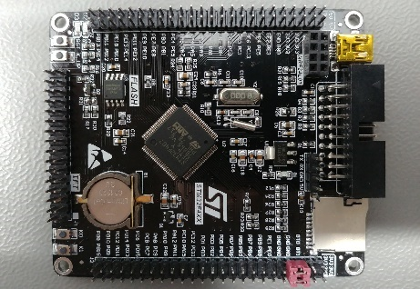

Fig 4: Jetson Nano

Fig 5: STM32 F4VE

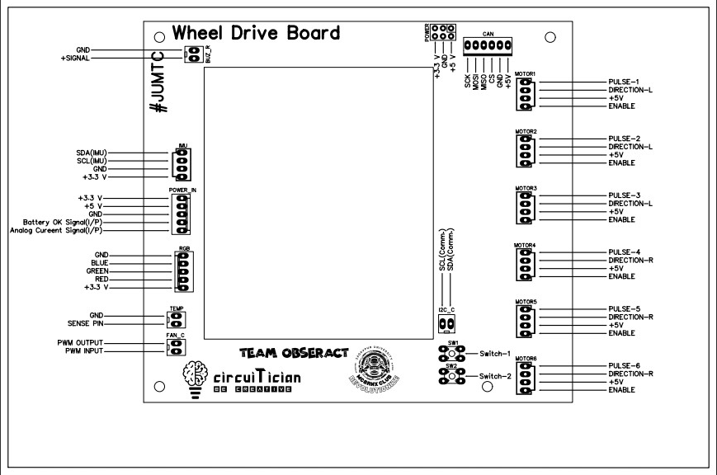

Fig 6: Customize Rover wheel Drive Board

- Jetson Nano Computer: This onboard computer acts as the high-performance brain for sensor data fusion and autonomous decision-making:
  - It fuses data from the Inertial Measurement Unit (IMU) and camera sensors to create a comprehensive understanding of the rover's environment. Sensor data includes the rover's orientation, acceleration, and angular velocity from the IMU, along with visual information from the camera sensor.
  - A deep learning model integrated within the Jetson Nano enables real-time obstacle avoidance and crater detection. The deep learning model is pre-trained on a vast dataset of outer space terrain imagery, allowing it to identify and localize obstacles and craters with high accuracy.
  - The Jetson Nano communicates with the STM32 microcontroller, translating high-level navigation commands (e.g., move forward, turn left) into actionable motor control instructions (e.g., adjust speed and direction of specific wheels). This communication ensures precise and coordinated movement of the rover.
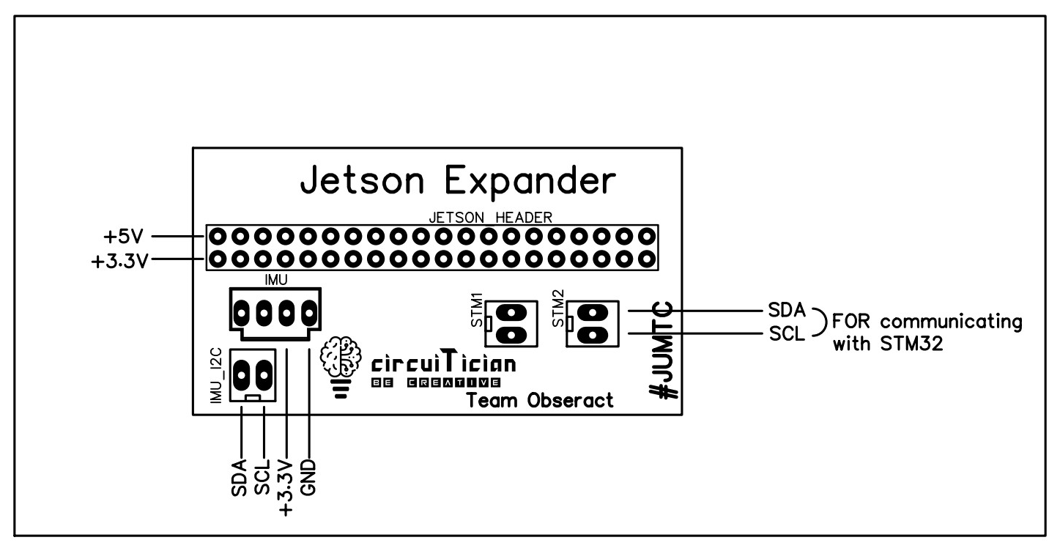

Fig 7: Customize Jetson Expander

3.1.3 Design calculations
- Rocker Bogie design:
Our rocker bogie has two major section with 100 degree span. The longest arm is 400 mm and the smaller arms are 160 mm each. The overall hight of this rover around 390 mm and overall length around 900 mm. Entire design made by Aluminium T slots.
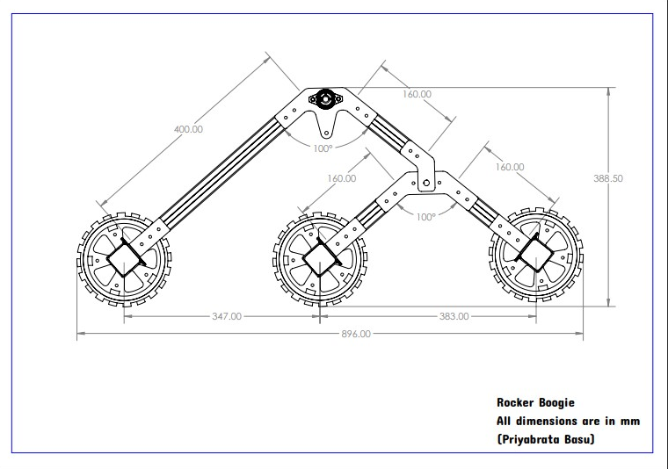

Fig 8: Rocker Bogie Dimension

- Wheel design:
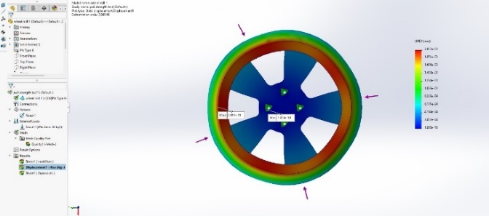
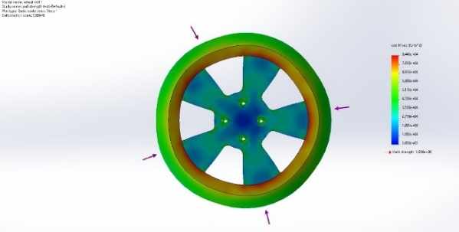

Fig 9: Wheel Pressure Test
Fig 10: Wheel Thermal Test

- Body design and Test:
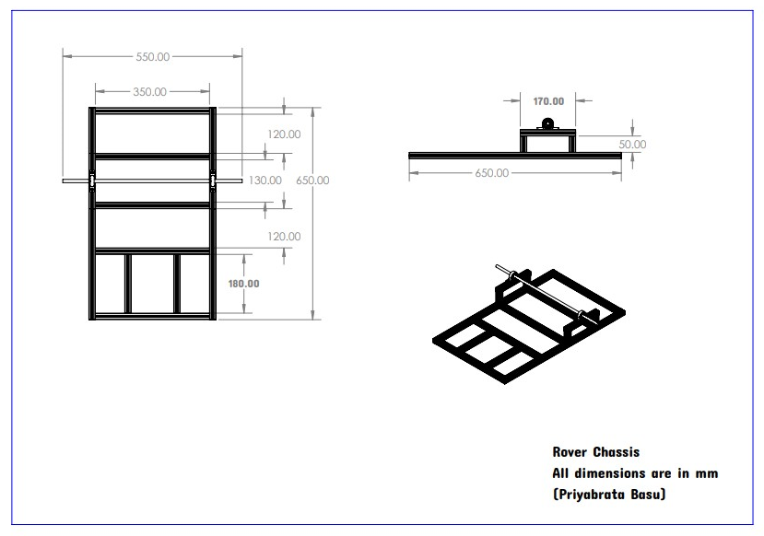

Fig 11: Rocker Bogie Dimension

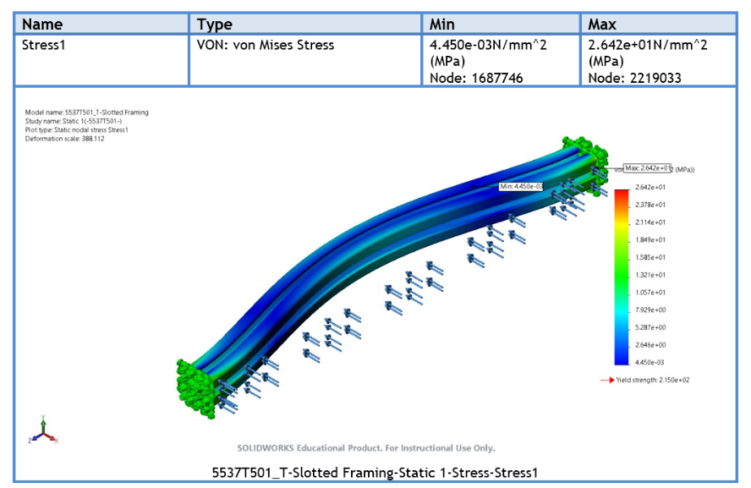
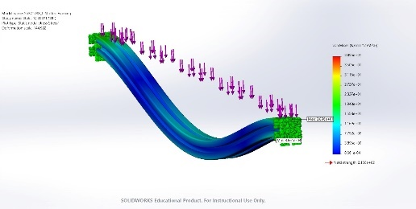
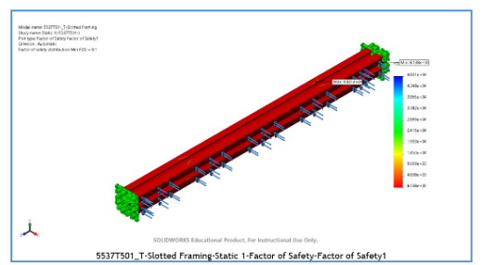
Fig 12: Test on Tslot

3.1.4. Sensor System
The mobility system leverages a suite of sensors to provide crucial feedback for navigation and control:
- IMU (Inertial Measurement Unit): Measures the rover's orientation (pitch, roll, yaw), acceleration, and angular velocity. This data is essential for maintaining balance and stability during maneuvers, particularly when traversing slopes or uneven terrain. The IMU's real-time feedback allows the system to make adjustments to motor control to ensure the rover remains upright and stable.
- Camera Sensor: Provides visual information for obstacle detection and crater identification. The camera sensor is carefully selected to be suitable for the harsh outer space environment, considering factors like radiation tolerance and extreme temperature fluctuations. The camera captures real-time images of the surrounding terrain, which are fed into the Jetson Nano for deep learning analysis.

3.1.5. Software Requirements and Design
Software development utilizes distinct platforms for different functionalities:
- STM32CubeIDE: This platform is used to develop low-level firmware for the STM32 microcontroller. The software encompasses:
  - Low-Level Motor Control: Manages communication with the motor drivers to control individual wheel speeds and directions with precision. This ensures precise movement and minimizes the risk of erratic behaviour or loss of control.
  - Sensor Data Acquisition: Reads data from the IMU for feedback and control purposes. Real-time IMU data is crucial for maintaining stability and enabling the rover to react to changes in terrain or orientation.
  - Safety Management: Implements critical safety features like current limiting and emergency stop functionality based on real-time sensor data. These features protect the rover's motors and electronics from damage in case of overload or critical situations.

- Jetson Nano Development Kit: This platform is used to develop high-level software for the Jetson Nano computer, including: *
The Jetson Nano Developer Kit from NVIDIA packs a powerful punch in a compact size. This AI computer empowers users to create and deploy real-world AI applications.

6. Specifications of COTS components

Component | Quantity | Description
Rocker-Bogie Suspension System:
* Rocker Frame | 1 | Central frame connecting the two bogies.
* Bogie Assembly (Left & Right) | 2 | Each bogie includes wheels and suspension components.
* Hard Nylon Wheel | 6 | Wheels with resilient rubber tires for traction.
* Wheel Hub and Bearings | 6 | Assembly for smooth wheel rotation.
* Suspension Linkages | (Set)
* Shock Absorbers (Optional) | 2 | To dampen impacts and improve handling (consider testing with and without).
Wheel Drive System:
* Bi-polar Planetary Geared Stepper Motor (24V, 54 kg-cm) | 6 | Motors for individual wheel control and precise movement.
* Stepper Motor Driver Board (x6 Channels) | 1 | Controls and regulates power delivery to each stepper motor.
Centralized Control System:
* STM32 Microcontroller Board | 1 | Processes sensor data and controls motor drivers for precise navigation.
* Cables and Connectors | As Needed | Connects all components within the mobility system.

Rover Mobility System Component List
Additional Considerations:
- Power Supply: 24V Lithium Ion Battery (not listed in table) to provide power for the entire mobility system.
- Sensors: While not explicitly listed here, consider including sensors like IMU (Inertial Measurement Unit) for orientation and stability data. The specific sensor selection will depend on the final implementation and chosen navigation strategy.
Quantity Notes:
- The rocker-bogie system includes two bogies, each requiring wheels, hubs, bearings, and linkages. Hence, the quantities for these components reflect the total needed for both bogies (e.g., 6 wheels for 3 wheels per bogie).
- The Stepper Motor Driver Board typically controls multiple motors simultaneously. A single 6-channel driver board can manage all six stepper motors in this design.

  - . Navigation and identification
The rover's mounted camera records video footage of its surroundings, while the latest YOLOv8 algorithm detects craters within this footage. YOLOv8, an object detection algorithm, utilizes supervised deep learning for lightweight object detection, classification, and segmentation, achieving state-of-the-art performance across various benchmarks. Utilizing this open-source model requires training data for target classes, thus, we manually captured and labeled 500 images of craters on the testing ground using LabelMe software. Craters were categorized into two classes based on their pixel count, distinguishing between 20cm and 40cm diameter. The model underwent 30 epochs of training on 80% of the data, with the remaining 20% used for testing, resulting in a remarkable 98% accuracy on the test set. Notably, this model not only accurately detects craters but is also lightweight, making it suitable for deployment on mobile devices like the Nvidia Jetson Nano. Its portability enables efficient crater detection, aiding in rover navigation throughout its exploration missions.
- Algorithms
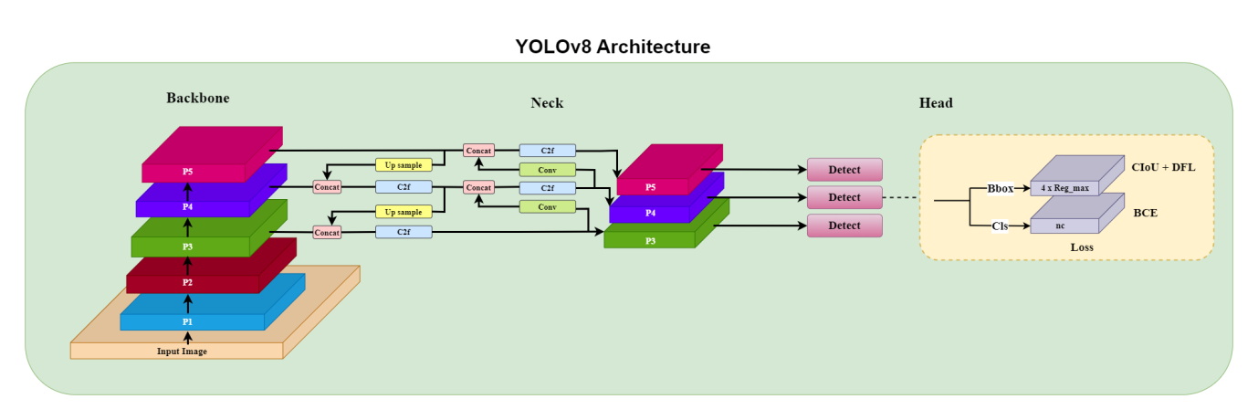

Fig 13: YOLO v8 Architecture

The YOLOv8 architecture represents a significant advancement in object detection, boasting improvements in detection speed and accuracy compared to its predecessors. It consists of three main components:
    - Backbone: YOLOv8 utilizes CSPDarknet53 as its backbone architecture, featuring 53 convolutional layers and 3 residual blocks. The Cross-Stage Partial (CSP) module within CSPDarknet53 aids in efficient feature extraction by incorporating two branches: a main branch and a residual branch. This design optimizes feature extraction efficiency without inflating the parameter count. Leveraging focus layers, CSPDarknet53 enhances feature map resolution by expanding channel depth, thereby enhancing YOLOv8's efficiency, speed, and accuracy.
    - Neck: YOLOv8's neck architecture employs the C2F module, which integrates outputs from convolutional layers to create a comprehensive feature map reflecting input image characteristics. Through subsequent convolutional layers, the C2F module integrates high-level features with contextual information, augmenting YOLOv8's accuracy by effectively blending features from various backbone layers.

    - Head: The head of YOLOv8 is responsible for object detection and classification. It introduces two pivotal elements: Anchor-free detection and a Decoupled head. Utilizing a center-based approach, YOLOv8 predicts object locations, while the Decoupled head comprises a classification branch for object class prediction and a regression branch for bounding box coordinate estimation. This modular head architecture enhances YOLOv8's adaptability across diverse object detection scenarios, outperforming previous iterations in flexibility and versatility.

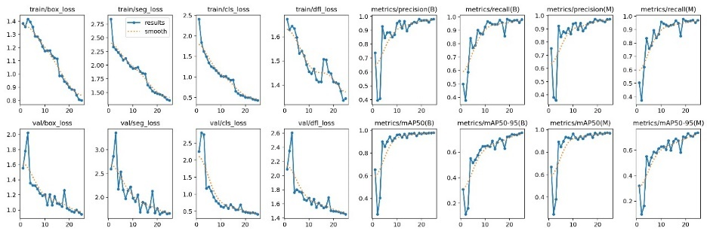

Fig 14: Training data for crater detection

- Software requirements and design details
The YOLOv8 architecture, depicted in the figure, has been trained using Categorical Crossentropy loss for classification, distinguishing between background and the two types of craters, and Intersection over Union (IoU) loss for precise crater localization in both ground truth and predictions. This model optimization occurs during training. The fluctuations in loss and accuracy across different training epochs for both the training and validation sets are illustrated in the accompanying figure.
A confusion matrix serves as a vital tool in machine learning for evaluating classification model performance. It offers a concise summary of correct and incorrect predictions made by the model on a given dataset. Organized into rows and columns, the confusion matrix juxtaposes predicted and actual class labels. The key components of the confusion matrix include True Positives (TP), False Positives (FP), True Negatives (TN), and False Negatives (FN). By analyzing these values, we assess the model's performance, aiming to minimize FP and FN errors. Notably, the model's ability to accurately detect craters is evidenced by the low occurrence of FP and FN instances, as observed in the figure.
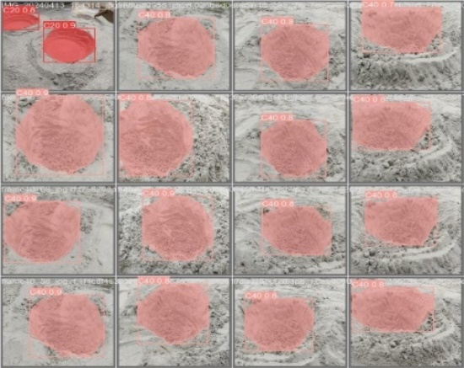
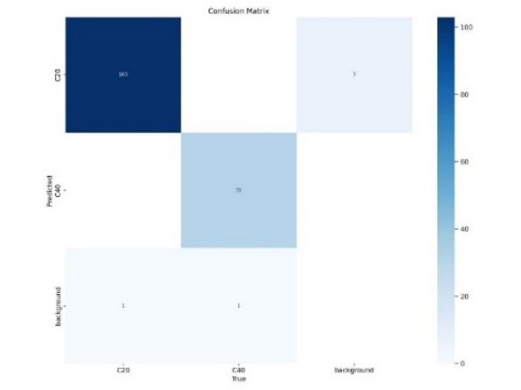

Fig 15: Test data for crater detection

Fig 16: Crater Detection

Furthermore, the detection results of craters, as determined by the YOLOv8 model, are showcased in the figure. These results are instrumental in guiding rover navigation to avoid craters, leveraging the precise crater locations identified by the model.

3.3 Manipulator
A robotic arm, sometimes referred to as a manipulator, is a kind of artificial arm used to carry out activities that people would find hazardous or impossible to complete. These jobs can range from carrying out surgery in a hospital to constructing goods in a factory. In sectors like automotive, electronics, and aerospace where accuracy and reliability are crucial, robotic arms are frequently employed. They are employed in the medical industry as well as in research and development. Robotic arms can move very precisely and consistently because of a computer programme that control them. They can be programmed to carry out a variety of tasks, such as welding, painting and pick-and-place operations. Robotic arms are becoming more prevalent in a wide range of applications and are a vital tool in many industries.

- Mechanism design

In this proposal, a 5-degree-of-freedom robotic arm is suggested for pick-and-place tasks. The arm comprises three revolute joints labelled as "R" and two twisted joints labelled as "T". The joints have been configured in a TRRT arrangement, as depicted in the kinematic diagram (fig 17) Stepper motors and servomotors have been considered as joint actuators.

Stepper motors have a good low-speed torque, which allows them to tow things from a standstill with greater horsepower. This feature also enables the motor to receive timely commands and synchronize its motion accordingly, making it a better choice than servo motors in some applications. Another advantage of stepper motors is their quick response when starting, resulting in a good low-speed workflow. They also have a compact size, which allows for energy savings due to their lightweight and simple design. Furthermore, stepper motors are more cost-effective than servomotors, making them a more affordable option for many applications. On the other hand, servomotors also have several advantages. They offer high accuracy and resolution. They also offer high dynamic performance, with the ability to start and stop quickly and smoothly. Servomotors are also capable of operating at high speeds and with high torque, making them suitable for a wide range of applications. Compared to other types of motors, such as AC induction motors or DC motors, stepper motors and servomotors offer greater precision and control. They are ideal for applications that require precise positioning, such as robotics, CNC machines, and 3D printing. While they may be more expensive than other types of motors, the increased precision and control they offer can make them well worth the investment.
The links of the manipulator have been developed with the aluminium rods. The advantages of using aluminium links in a manipulator include faster operation, lower energy consumption, and a reduction in cost for work. Aluminium links are lighter in weight, which leads to increased flexibility, allowing for high-speed and energy-efficient solutions. This is particularly important in industries where high-speed, energy-efficient, and cost-effective solutions are increasingly emphasized.
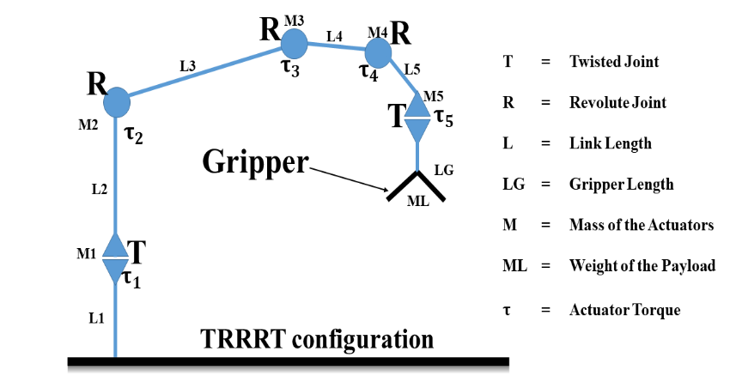

Fig 17: Robotic Arm link calculation

- Drive electronics design
- Arm Driver Board
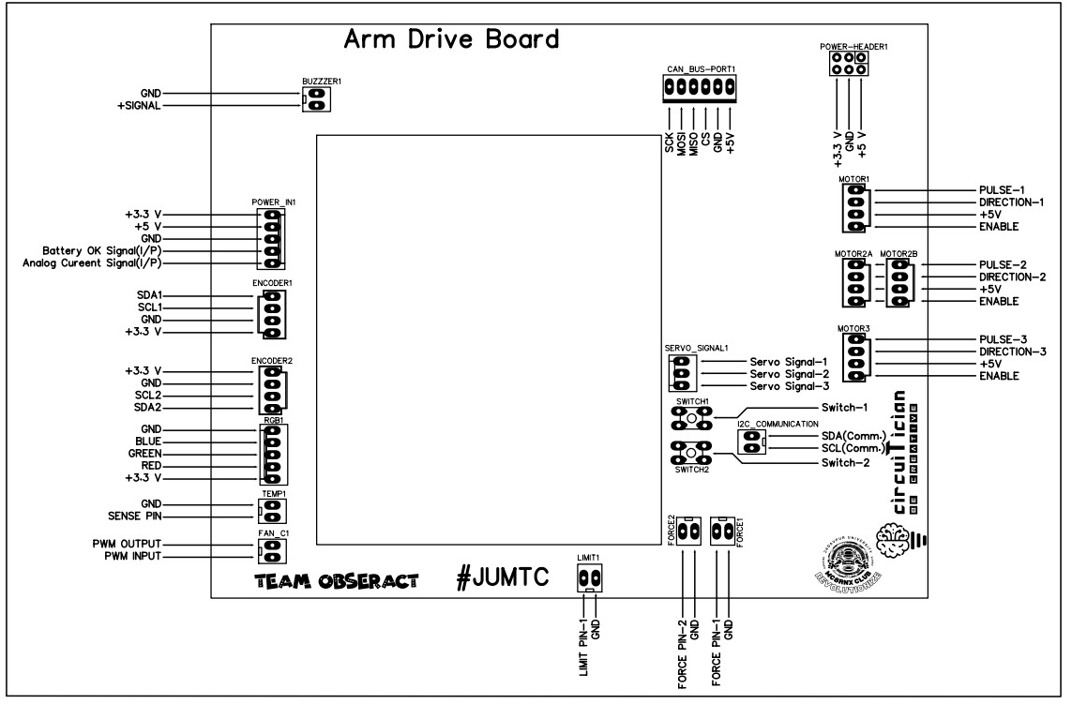

Fig 18: Arm Driver Board

- Encoder Board
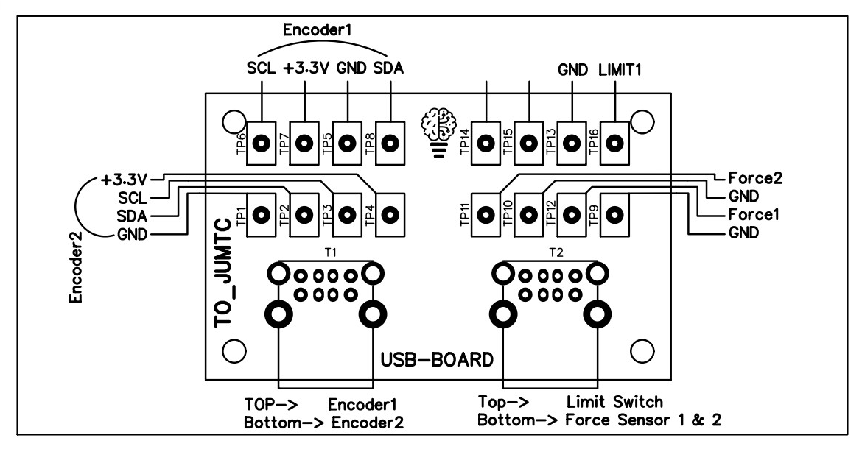

Fig 19: Encoder Development Board

- Design calculations

The mathematical model of the manipulator has been presented with the help of forward kinematics and inverse kinematics. Forward kinematics refers to the process of determining the end-effector position and orientation based on the joint angles of the manipulator. It is a direct calculation that uses the Denavit-Hartenberg parameters to calculate the transformation matrices for each joint and then multiplies them to find the end-effector position. Forward kinematics is useful for simulating the motion of the manipulator and for visualizing its configuration.
Inverse kinematics, on the other hand, refers to the process of determining the joint angles required to achieve a desired end-effector position and orientation. It is a more complex calculation that often involves solving nonlinear equations and can have multiple solutions. Inverse kinematics is useful for controlling the motion of the manipulator and for performing tasks such as picking and placing objects.
Let, $α$ = Twist axis between the z-axes of two consecutive links, $a$ = The distance between the z-axes of two consecutive links, $θ$ = The angle between the x-axes of the consecutive links and $d$ = The distance between the x-axes of two consecutive links. Considering the reference coordinate system presented in the D-H parameter can be given as

D-H parameter table:
Frame | $$θ_{i}$$ | $$d_{i}$$ | $$α_{i}$$ | $$a_{i}$$
1 | $$θ_{1}$$ | 0 | $$-{90}^{o}$$ | 0
2 | $$θ_{2}$$ | 0 | 0 | $$L_{1}$$
3 | $$θ_{3}$$ | 0 | 0 | $$L_{2}$$
4 | $$θ_{4}$$ | 0 | $${90}^{o}$$ | 0
5 | $$θ_{5}$$ | 0 | 0 | 0

Forward kinematics:
To determine the position and orientation of the end effector with respect to the base coordinate system, providing link length and joint angle is known.
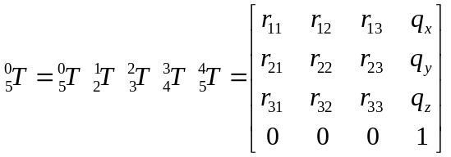
Where,

$r_{11}=\cos{θ_{1}}\cos\left(θ_{2}+θ_{3}+θ_{4}\right)\cos{θ_{5}}-\sin{θ_{1}}\sin{θ_{5}}$
$r_{12}=-\cos{θ_{1}\cos\left(θ_{2}+θ_{3}+θ_{4}\right)\sin{θ_{5}} -\sin{θ_{1}}\cos{θ_{5}}}$
$r_{13}=\cos{θ_{1}}\sin{(θ_{2}+θ_{3}+θ_{4})}$
$r_{21}=\sin{θ_{1}}\cos\left(θ_{2}+θ_{3}+θ_{4}\right)\cos{θ_{5}}+\cos{θ_{1}}\sin{θ_{5}}$
$r_{22}=-\sin{θ_{1}}\cos\left(θ_{2}+θ_{3}+θ_{4}\right)\sin{θ_{5}}+\cos{θ_{1}}\cos{θ_{5}}$
$r_{23}=\sin{θ_{1}}\sin{(θ_{2}+θ_{3}+θ_{4})}$
$r_{31}=-\sin\left(θ_{2}+θ_{3}+θ_{4}\right)\cos{θ_{5}}$
$r_{32}=\sin{(θ_{2}+θ_{3}+θ_{4})}\sin{θ_{5}}$
$r_{33}=\cos\left(θ_{2}+θ_{3}+θ_{4}\right)$
$q_{x}=\cos{θ_{1}}\left(L_{1}\cos{θ_{1}}+L_{2}\cos\left(θ_{2}+θ_{3}\right)\right)$
$q_{y}=\sin{θ_{1}}\left(L_{1}\cos{θ_{1}}+L_{2}\cos\left(θ_{2}+θ_{3}\right)\right)$
$q_{z}=-L_{1}\sin{θ_{2}}-L_{2}\sin{(θ_{2}+θ_{3})}$

Inverse Kinematics:
Objective is to determine joint angles: $θ_{1} ,θ_{2} ,θ_{3} , θ_{4} , θ_{5}$ , when forward kinematics is known.
$θ_{1}=\arctan\left(\frac{q_{y}}{q_{x}}\right)$
$θ_{2}=\arctan\left(\frac{L_{1}+L_{2}\cos{θ_{3}}}{L_{2}\sin{θ_{3}}}\right)-\arctan\left(\frac{q_{x}\cos{θ_{1}}+q_{y} \sin{θ_{1}}}{{-q}_{z}}\right)$
$θ_{3}=\arccos\left(\frac{q_{x}^{2}+q_{y}^{2}+q_{z}^{2}-L_{1}^{2}-L_{2}^{2}}{2 L_{1} L_{2}}\right)$
$θ_{4}=\arctan\left(\frac{r_{13}\cos{θ_{1}}+r_{23} \sin{θ_{1}}}{r_{33}}\right)-θ_{2}-θ_{3}$
$θ_{5}=\frac{r_{21}\cos{θ_{1}}-r_{11} \sin{θ_{1}}}{r_{22}\cos{θ_{1}}-r_{21} \sin{θ_{1}}}$

The flow diagram presented in the (fig 20). Shows how the forward and inverse kinematics have been used to obtain the necessary information of manipulator’s link and end effector. At first the sensors detects the initial position of the links of the manipulator. Those data are used by the forward dynamics, whose job is to calculate the position and orientation of the end effector. The information of the initial position of the end and the desired end position provided by the other sensor units have been analysed by the inverse kinematics. The purpose of inverse kinematics is to generate the required joint angles needed to make the end effector reach the desired position.
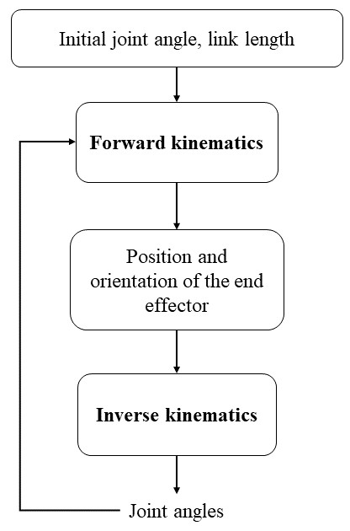

Fig 20: Flowchart of Arm Movement

- Sensor system

- Force Sensor (typically in the gripper):
  - Feels the grasping force applied by the gripper.
  - Prevents damage to delicate objects by detecting excessive force.
  - Helps maintain a firm yet gentle grip on the object.

- Limit Switch (usually at the joints):
  - Acts like a physical stop switch at the end of a joint's movement range.
  - Prevents overextension or damage to the arm by stopping motor movement when a limit is reached.
  - Ensures the arm stays within its safe operating range.

- Specifications of COTS components:

Rover Robotic Arm Component List
Component | Quantity | Description
Arm Structure:
* Base Plate | 1 | Base for attaching the arm to the rover body.
* Arm Links (Upper, Lower, etc.) | (Set) | Lightweight and rigid links forming the main structure of the arm.
* Joints (Rotational or Prismatic) | (Set) | Depending on the design, these allow for movement along different axes.
* Bearings | (Set) | Reduce friction and enable smooth joint movement.
Motors:
* Stepper Motor (Base, Shoulder, Elbow) | 3 | High precision motors for core arm movements.
* Servo Motor (Rest of Arm, Gripper) | (Variable) | Number depends on design complexity. Suitable for smooth and continuous control.
Sensors:
* Force Sensor (Gripper) | 1 | Measures grasping force to prevent object damage.
* Limit Switch (Gripper) | 2 | Indicates the full range of gripper motion for safe operation.
* Encoders (Motor-mounted) | 2 | Provide real-time feedback on motor position for precise arm control (one for each stepper motor).
Control System:
* STM32 F406 Microcontroller Board | 1 | Controls motor drivers and processes sensor data for arm movement.
* Motor Driver Board (for Stepper Motors) | 1 | Regulates power delivery to the stepper motors.
* Servo Controller Board (for Servo Motors) | (Optional) | May be needed depending on the chosen servo motors (some integrate drivers).
* Cables and Connectors | As Needed | Connects all components within the robotic arm system.

Quantity Notes:
- The number of arm links and joints depends on the specific design and degrees of freedom of the robotic arm.
- The quantity of servo motors is variable depending on the chosen design complexity. More complex arms with additional joints may require more servo motors.
- Some servo motors integrate their own driver boards, eliminating the need for a separate servo controller board.

Additional Considerations:
- Gripper Design: The gripper design may include additional components like fingers or grasping mechanisms depending on the intended objects for manipulation.
- Power Supply: While not listed here, a power source is required to operate the motors and electronics within the robotic arm system. This could be the same 24V Lithium-Ion battery powering the mobility system.

  - Communications
- RF design
This report analyses the suitability of the Ubiquiti Networks LBE-M5-23 5GHz antenna for point-to-point communication in the context of a Rover mission. While this particular antenna model may not be ideal for deployment due to space environment limitations, it serves as a valuable educational tool for understanding directional antennas and their role in establishing communication links.

- Design calculations

- Operational Principles
The LBE-M5-23 functions as a directional antenna, focusing radio waves in a specific direction to maximize signal strength for long-distance communication. Here's a simplified breakdown of its functionality:
- Data Transmission:
  - The rover's communication module transforms digital data into a radio signal at the 5 GHz frequency.
  - This signal is channelled into the LBE-M5-23 antenna.
  - The antenna's design concentrates the radio waves into a narrow beam, directing the signal toward the receiving antenna (another LBE-M5-23) situated at the base station.
- Data Reception:
  - The receiving LBE-M5-23 antenna at the base station captures the directional radio waves transmitted from the rover.
  - The antenna focuses the received signal and feeds it to the base station's communication module.
  - The communication module decodes the radio signal back into its original digital data.

- Power Requirements: Communication Protocols
The LBE-M5-23 antenna itself is agnostic to communication protocols. It can be used with various protocols depending on the communication modules chosen for the rover and base station. Common options for point-to-point communication include:
- TCP/IP: The standard internet protocol suite, ensuring reliable data transfer with error correction capabilities.
- UDP: A connectionless protocol offering faster data transfer but without error correction, suitable for real-time applications where speed is more critical than guaranteed delivery.
    - Proprietary Protocols: Manufacturers may provide their own communication protocols optimized for their specific equipment.
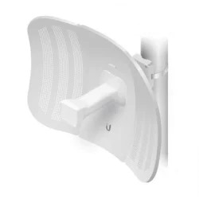

Fig 21: LBE-M5-23 antenna

- Software requirements and design details

  - The LBE-M5-23 typically receives power via a PoE (Power over Ethernet) injector, providing both data and power through a single Ethernet cable. This setup simplifies deployment but may not be compatible with the Rover's power system.
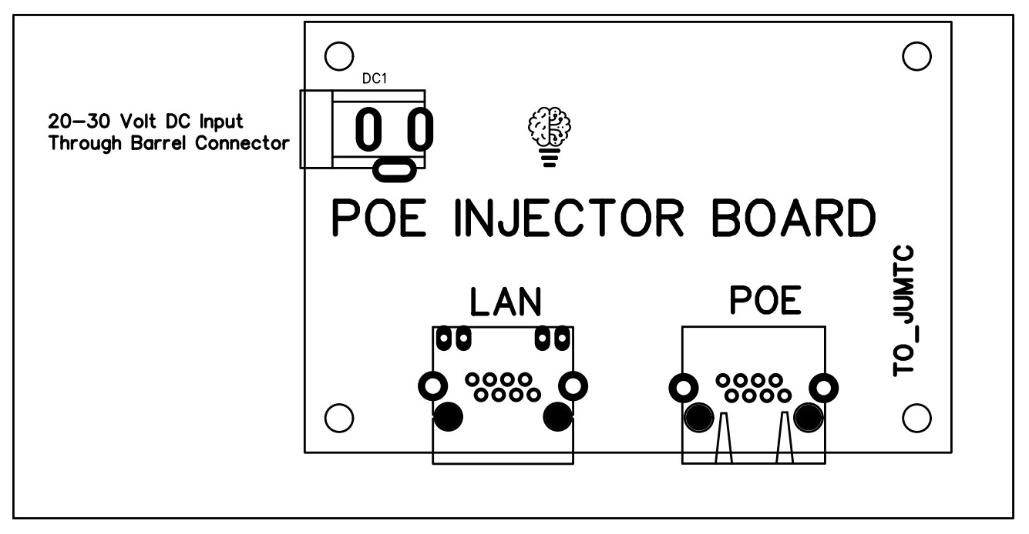

Fig 21: Antenna power and communication board

- Specifications of COTS components
The selected antenna, the Ubiquiti Networks LBE-M5-23, leverages a globally unrestricted 5 GHz frequency band. This characteristic facilitates communication without requiring specific licensing. Furthermore, the antenna boasts a substantial gain of 23 dBi, achieved through its directional design. This configuration concentrates radio waves into a focused beam, maximizing signal strength for extended communication ranges. The LBE-M5-23 incorporates dual linear polarization, a feature that enhances signal reception compared to traditional single-polarization antennas. The antenna's compact size and lightweight construction make it a suitable candidate for integration within the Rover's design constraints.

  - Power Distribution and Emergency response system
A customized power distribution board (PDB) acts like the heart of your project's electrical system. It takes raw power from a source (battery, AC outlet) and distributes it safely and efficiently to various components
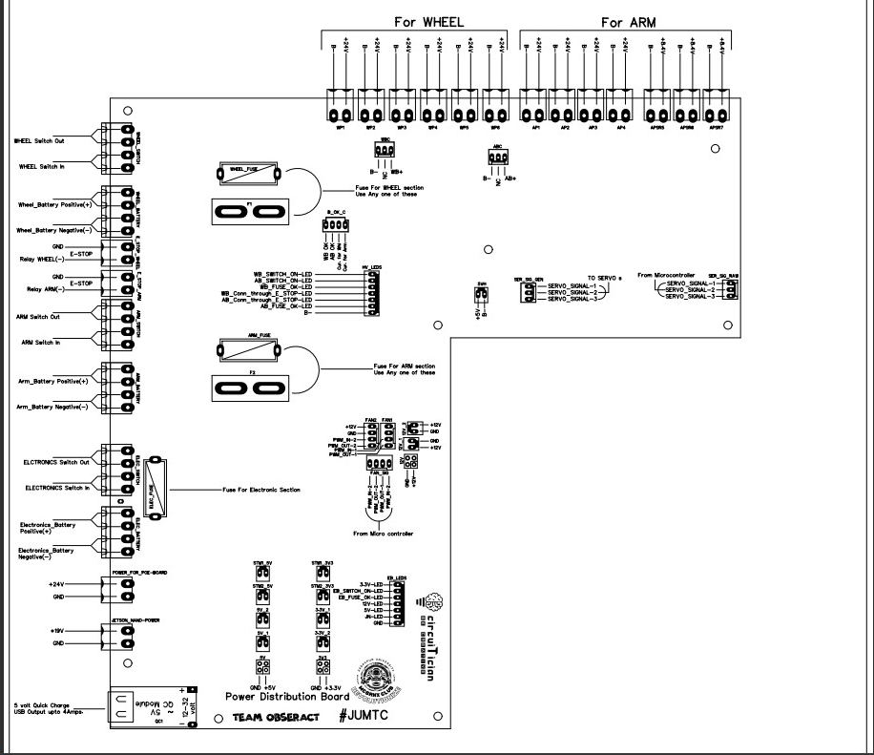

  - Kill switch design

Fig 22: Customise power distribution board

3.6. Analysis
This report presents a critical analysis of the Rover design, encompassing its mobility system, robotic arm functionality, and overall performance and efficiency. The design exhibits promising features for outer space exploration, but opportunities for improvement exist to optimize performance and efficiency for a successful mission.
- Mobility System
The implemented rocker-bogie suspension system offers significant advantages:
- Enhanced Stability: Independent bogie articulation allows each wheel to conform to uneven terrain, minimizing the risk of tipping over during maneuvers.
- Improved Maneuverability: Differential control of wheels on each bogie facilitates tight turns and precise navigation through obstacles.
- Increased Obstacle Clearance: High ground clearance enables the rover to traverse over rocks, craters, and other outer space surface challenges.
However, the selection of stepper motors for wheel actuation warrants further investigation. While they offer precise control, stepper motors are generally less energy-efficient compared to brushless DC motors. Evaluating alternative motor options could potentially improve the rover's operational range on a single battery charge.

- Robotic Arm
The design incorporates a strategic combination of stepper motors and servo motors:
- Stepper Motors (Base, Shoulder, Elbow): Provide the necessary precision for core arm movements, ensuring accurate positioning during sample acquisition tasks.
- Servo Motors (Rest of Arm, Gripper): Offer smooth and continuous control well-suited for delicate grasping and manipulation activities.
The inclusion of a force sensor and limit sensor in the gripper enhances control and safety during sample handling. Encoders on both motors provide real-time feedback for precise positioning, crucial for successful object manipulation.

- Centralized Control System
The decision to utilize an STM32 F406 microcontroller for the robotic arm and a Jetson Nano computer for overall navigation leverages the strengths of each system:
- STM32 F406: Due to its efficient processing power, it excels at real-time control of the robotic arm, ensuring precise and responsive movement during operations.
- Jetson Nano: Ideal for high-level tasks like sensor data fusion, obstacle detection, and overall navigation planning, owing to its superior processing capabilities for complex algorithms. This centralized control system architecture promotes efficient task distribution and optimized system performance.
- Performance and Efficiency Considerations
Strengths:
- Robust Mobility System: The rocker-bogie design provides excellent stability and maneuverability, enabling efficient navigation on the outer space surface.
- Versatile Robotic Arm: The combination of stepper and servo motors offers a balance between precise positioning and smooth manipulation, crucial for effective sample acquisition.
- Sensor Integration: The force sensor and limit switches in the gripper improve safety and precision during sample handling activities.
- Centralized Control System: The STM32 F406 ensures real-time control of the robotic arm, while the Jetson Nano facilitates high-level decision-making and navigation planning, promoting coordinated operation.

      - Test plan
This document outlines a comprehensive test plan designed to evaluate the Rover's performance under various conditions relevant to outer space exploration. The plan incorporates a series of controlled activities mimicking potential outer space surface scenarios and addresses the specific tasks requested by the ISRO team for video demonstration.
7.1. Test Objectives
- Mobility Assessment:
  - Evaluate rover's stability and manoeuvrability on flat surfaces and inclines.
  - Assess obstacle-climbing capabilities.
  - Measure crater traversal effectiveness.
- Robotic Arm Functionality:
  - Demonstrate sample pickup and placement accuracy.
  - Verify autonomous operation of the robotic arm.
- Sensor Integration and Path Planning:
  - Validate obstacle and crater detection using onboard sensors.
  - Assess real-time path planning and obstacle avoidance capabilities.
- Telemetry and Communication:
  - Verify transmission of sensor data and live path planning information.
  - Confirm successful image transmission of obstacles, craters, and samples.
  - Demonstrate functionality of the kill switch for emergency shutdown.
7.2 Test Activities and Procedures
- Mobility Assessment
Activity 1: Mobility on 0° Slope
- Description: The rover traverses a flat surface at a constant velocity.
- Performance Metric: Observe stability and smoothness of movement.
Activity 2: Mobility on 15° Slope (1 cm/sec - 5 cm/sec)
- Description: The rover climbs a 15° incline at varying velocities within the specified range.
- Performance Metric: Measure successful ascent of the slope without slipping or losing traction. Monitor motor performance and temperature.
Activity 3: Obstacle Climbing (150 mm x 150 mm x 150 mm Cube)
- Description: The rover autonomously navigates over a 150 mm cube obstacle placed 1 meter away on a flat surface.
- Performance Metric: Observe successful traversal of the obstacle without tipping or getting stuck. Measure time taken to complete the task.
Activity 4: Crater Traversal (200 mm Diameter Hemispherical)
- Description: The rover autonomously navigates across a 200 mm diameter hemispherical crater positioned 1 meter away on a flat surface.
- Performance Metric: Observe successful traversal of the crater without getting stuck or losing balance. Measure time taken to complete the task.
- Obstacle and Crater Avoidance
Activity 5: Obstacle Avoidance (300 mm x 300 mm x 300 mm Cube)
- Description: The rover autonomously travels 1.5 meters while avoiding a 300 mm cube obstacle placed 0.5 meters from the starting point.
- Performance Metric: Measure the distance traveled before stopping or colliding with the obstacle. Assign penalty points for mid-way stoppages or contact with the cube.
Activity 6: Crater Avoidance (400 mm Diameter Hemispherical)
- Description: The rover autonomously travels 1.5 meters while avoiding a 400 mm diameter hemispherical crater placed 0.5 meters from the starting point.
- Performance Metric: Measure the distance traveled before stopping or entering the crater. Assign penalty points for mid-way stoppages or entry into the crater.
- Robotic Arm Functionality
Activity 7: Sample Pick and Place
- Description: The robotic arm picks a sample tube (weight and dimensions specified) from the ground, avoiding ground contact once the object is grasped. The rover then travels 0.5 meters and places the sample tube on the ground autonomously.
- Performance Metric: Observe successful pickup, travel, and placement of the sample tube without dropping or mishandling it.
- Telemetry and Communication
Activity 8: Live Telemetry Feed
- Description: The rover transmits sensor data, live path planning information (graphical or coordinates), and images of encountered obstacles, craters, and the sample tube to a designated receiver (laptop).
- Performance Metric: Verify successful transmission of all data streams with minimal latency or signal loss.
Activity 9: Kill Switch Demonstration
- Description: While the rover is in motion, the kill switch is activated to demonstrate immediate power cutoff to all actuators.
- Performance Metric: Observe immediate cessation of all rover movement upon activation of the kill switch.

  - Weighing and dimensional measurement details of the rover
- Overall Assessment
The Rover design demonstrates a promising foundation for lunar exploration. By addressing the identified areas for improvement, the design can be further optimized to achieve superior performance and efficiency.
Rover Specifications
- Length: 87 cm
- Width: 67 cm
- Height: 60 cm
- Weight: 37 kg
The compact size and lightweight construction of the rover contribute to its maneuverability and efficient use of resources. However, during the development process, it's crucial to consider the total mission payload weight, including scientific instruments, sample containers, and any additional components.

Conclusion
The Rover design exhibits significant potential for lunar exploration tasks. By incorporating the recommendations from this analysis and conducting thorough testing, the rover's performance and efficiency can be further enhanced, paving the way for a successful mission. The presented dimensional and weight specifications provide a starting point, but it's essential to refine them throughout the development process to ensure the rover can accommodate all mission requirements within the payload limitations.

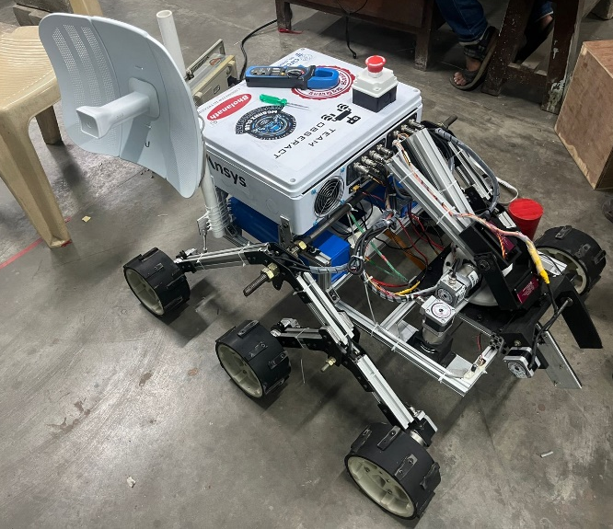
Fig 23: Rover OBSERACT

